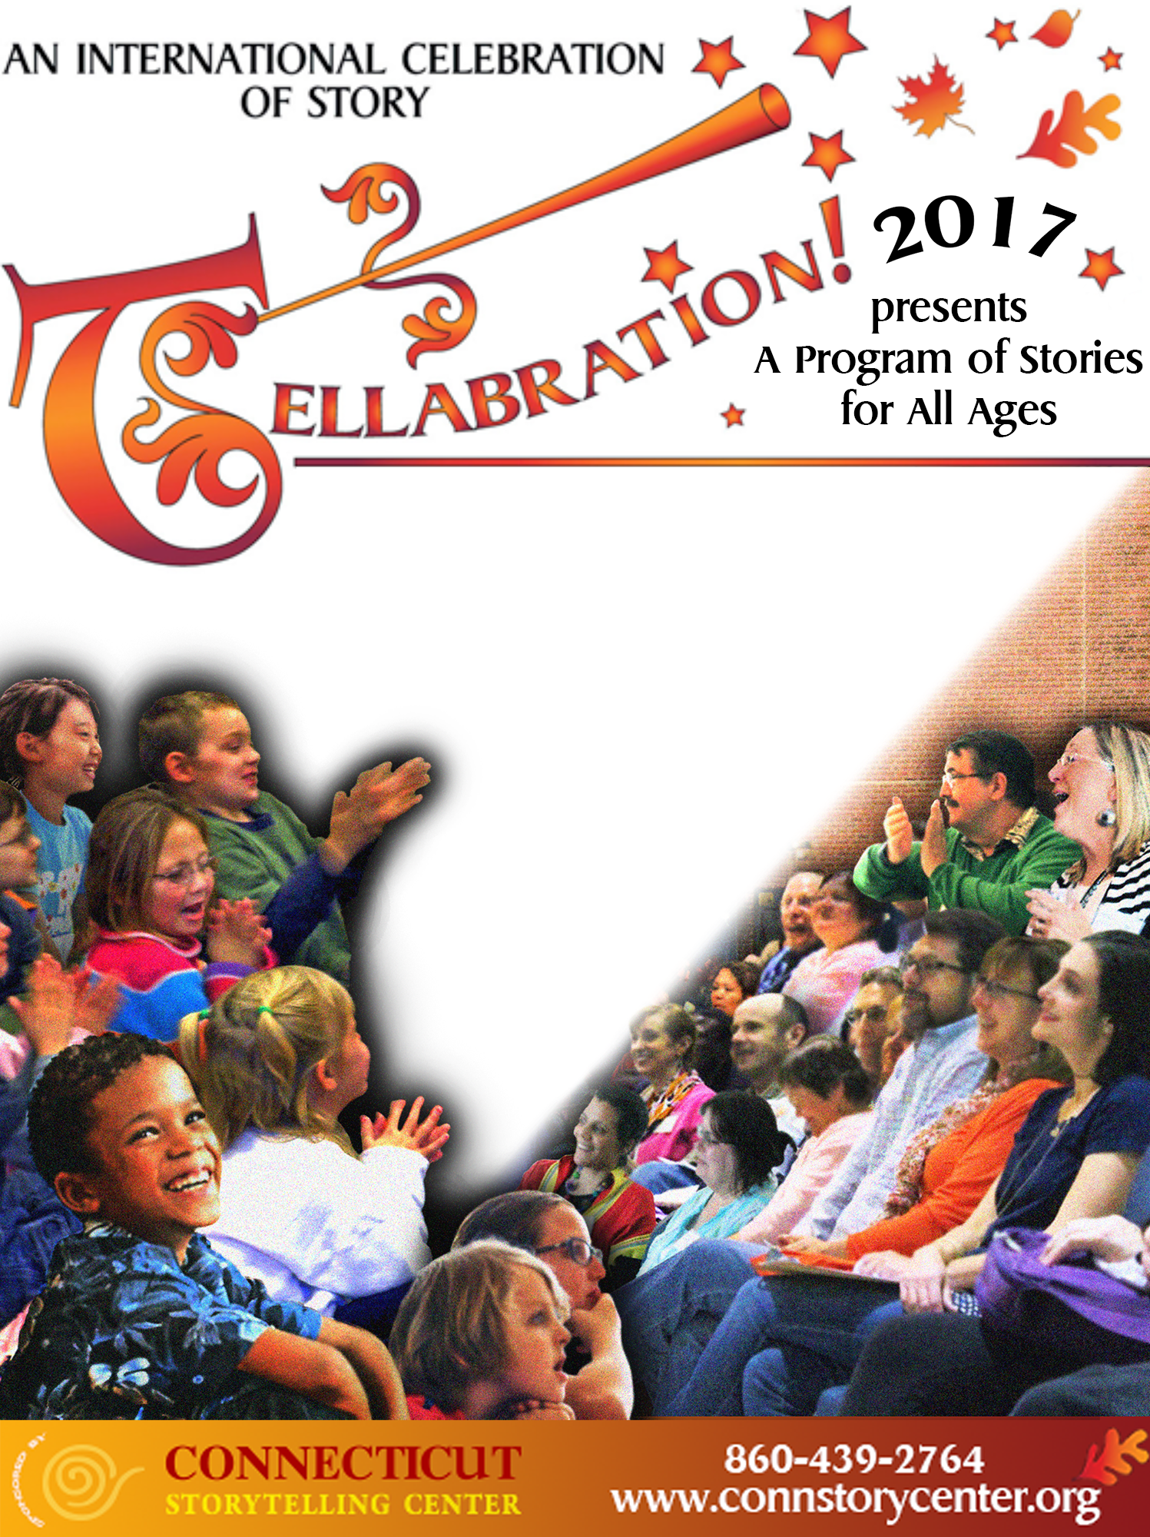
Dragon’s Egg
401 Shewville Road, Ledyard, CT
www.dragonseggstudio.org
Sunday, November 19
Time: 4:00 pm
With Carl Peruzzotti,
Mystic Paper Beasts,
Diane Postoian,
Susie Scheyder, and
Morning Glory

For more information
Marya Ursin
860-535-3346
mybeasts@aol.com

